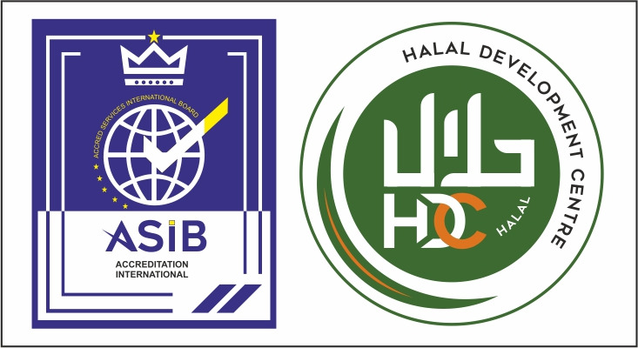

APPLICATION FOR ACCREDITATION

ASIB-HDC:1955-1:2022
Halal Conformity Bodies
www.asib.co.uk

ASIB -Form A07-2022. Effective Date: 1st September 2022.

PART 1 – 1.1 Organizational Information

Organisation Name
Trade name
Holding company (if appropriate)
Relationship with other entities*
(if appropriate)
Legal form of registration | Proprietorship Partnership Private Limited  Others (specify):
Govt licence / registration number
Registered business activity
Services offered by organization
Address
Postal code |  | State
City |  | Country
Telephone |  | Fax
E-mail (general) |  | website
Name of the contact person
Telephone / Mobile Number |  | E-mail
Accreditations held (if appropriate)
Name of AB & Scope
* for all new applications and only when there are changes for application for extension of scope.

1.2 Key Personnel (Key personnel are persons in a managerial position or persons having a specific or unique expertise which is critical for the activities to be accredited.)
Name (with initials & titles) | Designation | Qualification | Total Experience (in years)

1.3 Personnel involved in accreditation activities
 | Employed | Subcontracted
Administration staff
Technical personnel (auditors)
Technical Experts
Supporting staff
Others

Scope Applied:

Halal Conformity Bodies as per ASIB-HDC:1955-1:2022

Testing

Training

1.2 Locations with key certification activities (Critical locations, own locations of organization)
Name and complete address  (incl. country) of the location (site) | - Specify the certification activities that are carried out at this location.
 | - Head office
 | - Branch
Add new rows if necessary

PART 2 – Activity Scope

Halal Conformity Assessment Bodies:

Category Codes | Category | Product / Sectors  Products Group | Products Specification /  Standards

Guidance table for specify the accreditation:

Category Codes (Select the required Code) | Categories | Type of Product
A | Farming 1 (Animals) | Raising animals used for meat production milk production  Farming of Animals for Meat/ Milk Growing, keeping, trapping, and hunting (slaughtering at point of hunting), Associated packaging and storage
B | Farming 2 (Plants) | Fruits and vegetable, grains, spices and horticultural products
C | Processing 1 (Perishable animal products) including all activities after animal farming | Halal Slaughtering  Processed animal products  Meat based processed food
D | Processing 2 (Perishable vegetal products) | Canned products, biscuits, snacks, oil, beverages, pasta, flour
E | Processing 3 (Products with long shelf life at ambient temperature) | Processed vegetables products Examples: Fresh fruits and fresh juices; preserved fruits; fresh vegetables; preserved vegetables
F | Feed production | Animal feed; fish feed
G | Catering | Halal food catering service
H | Distribution | Retail outlets, shops, wholesalers
I | Services | Halal products services such as veterinary service for Halal animals
J | Transport and storage | Halal products logistics
K | Equipment manufacturing | Process equipment vending machines
L | (Bio)chemical manufacturing | Food additives, vitamins, drugs fertilizers, cleaning agents, biocultures
M | Packaging material manufacturing | Primary packaging materials coming into contact with Halal food
N | Other materials manufacturing | Cosmetics, textile, leather products, etc.

Attachments Required:
Company License, Government license to operate Lab, Approvals, Brochures, photos, and other information to support the scope of activity and the application.

PART 3 – ASIB/ HDC Accreditation Application Requirements

- ASIB accredits certification bodies to the international standard, ASIB-HDC:1955-1:2022, on demonstration of their competence to carry out specific conformity assessments for which accreditation is sought
- Certification bodies/Laboratories shall implement and demonstrate the competence required by the ASIB-HDC:1955-1:2022.
- ASIB will check the admissibility of your application. If it is admissible, we would send you a confirmation of acceptance of the application, accreditation process, and checklist. If the Laboratory body is already accredited by another AB, the process will differ and be communicated.
- If we do not consider your application complete or incorrect, we will notify you by giving a list of the missing documents or the needed corrections and the period within which the application can be completed and/or corrected.
- This application is only valid for one year. If an applicant cannot obtain accreditation within one year from the date of this application, a new application form and fee must be submitted.
- The filled-in application shall be duly signed and stamped by the responsible person of the certification body and shall be sent along with the required details and the documents to admin@asib.co.uk.
- If you need assistance with completing this form or the supplementary application form, please do not hesitate to contact us. We will be happy to help you. Please note that for SEA, India, and Middle East Region, you shall contact JAS Global (Our Associates) at +91-7397690467 (or) rajan@asib.co.uk and obtain the necessary details

Part 4 – Declaration

- The Certification body above applies for accreditation for the scope set out in this application.
- I hereby declare that the information on this form and any other information given in support of this application is correct to the best of my knowledge.
- I shall declare any outstanding issues of the certification body (such as previously held accreditation including the name of the accreditation body, accredited scopes, any cases of accreditation withdrawal, scope reduction or refusal of accreditation, non-compliances with legal requirements, etc.) to ASIB prior to the signing of accreditation.
- By signing this application, we agree to the General Terms and Conditions of ASIB and the client in Agreement D02. The current version of the terms and conditions is available on the website. It is understood by both parties that the document is read, understood, and downloaded for record purposes by the client.

 | Application Filled by: |  | Official Stamp
 | Designation:
 | Date:

